Times New Roman 10 fonts Centered and Bold in Upper- and Lowercase

First Name Last Name (Surname) ¹, First Name Last Name (Surname) ² and First Name Last name (Surname)* ^{3*}

¹Department/Research Institute, University, Country
²Department/Research Institute, University, Country, presenting author
^{3*}Department/Research Institute, University, Country, corresponding author (email optional)

Important:
Kindly follow this template to prepare the abstract. It should be limited to 1 page (submit only in pdf format).
The abstract should be sent via e-mail to abstract@anmportugal.com
The abstracts will be peer reviewed and the notification will be sent within 10 days of the receipt of the abstract. If you don’t receive a response within 10 days, please write to info@anmportugal.com

ANM2020 (www.advanced-nanomaterials-conference.com) will host seven simultaneous conference sessions namely,
(ANM) Advanced Nano Materials (topics include: nanomaterials, nanoelectronics, nanoenergy, nanomedicine, nanomechanics)
(AEM) Advanced Energy Materials (topics include: energy-materials, solar energy, alternative energy, wind energy, photovoltaics, photocatalysis supercapacitors, batteries, theoretical modeling )
(AGM) Advanced Graphene Materials (topics include: graphene materials, nanoelectronics, nanoenergy, nanomedicine, nanomechanics)
(AMM) Advanced Magnetic Materials (topics include: magnetic materials, spintronics materials, nanoelectronics, nanoenergy, nanomedicine, nanomechanics)
(APM) Advanced Polymer Materials (topics include: polymer-materials, nanocomposites, nanoelectronics, nanoenergy, nanomedicine, nanomechanics)
(OLED) Organic Light Emitting Diodes (topics include: organic nanoelectronics, inorganic nanoelectronics, hybrid nanoelectronics materials, quantum electronics,
organic light emitting diodes, hybrid nanoelectronics materials, quantum electronics
(HE) Hydrogen Energy (topics include: hydrogen-energy, hydrogen-production, nanoenergy, biofuels, theoretical- modeling)
(SEM) Solar Energy Materials (topics include: nanomaterials, organic solar cells, inorganic solar cells, thinfilm solar cells)
The e-mail’s (abstract@anmportugal.com) Subject should include the session, topic and type of work you wish to present in the following format: (Session-Topic-Poster).
Example. ANM-nanomaterial-Poster
AEM-Energy Materials-Oral
AMM- magnetic materials-Oral
APM- polymer materials- Oral
ANE- hybrid nanoelectronics material-Poster
HE-fuel cells-Poster

INTRODUCTION
The introduction should be simple and graspable to colleagues from other fields also. Please mention the novelty of the work and possible application in the introduction. References must be added in the text with superscripts¹.
EXPERIMENTAL/THEORETICAL STUDY
The specific techniques or procedure used in conducting this study can be explained briefly here. Subheadings can be used to differentiate the different methods in this section.
RESULTS AND DISCUSSION
In this section, try to present the data as concisely and clearly as possible. Figures, Tables and Scheme can be included. Example Fig. 1, Table 1, Scheme 1 etc.
There should be enough information for the reader to understand, but it is not necessary to write an extensive text to explain all the detail.

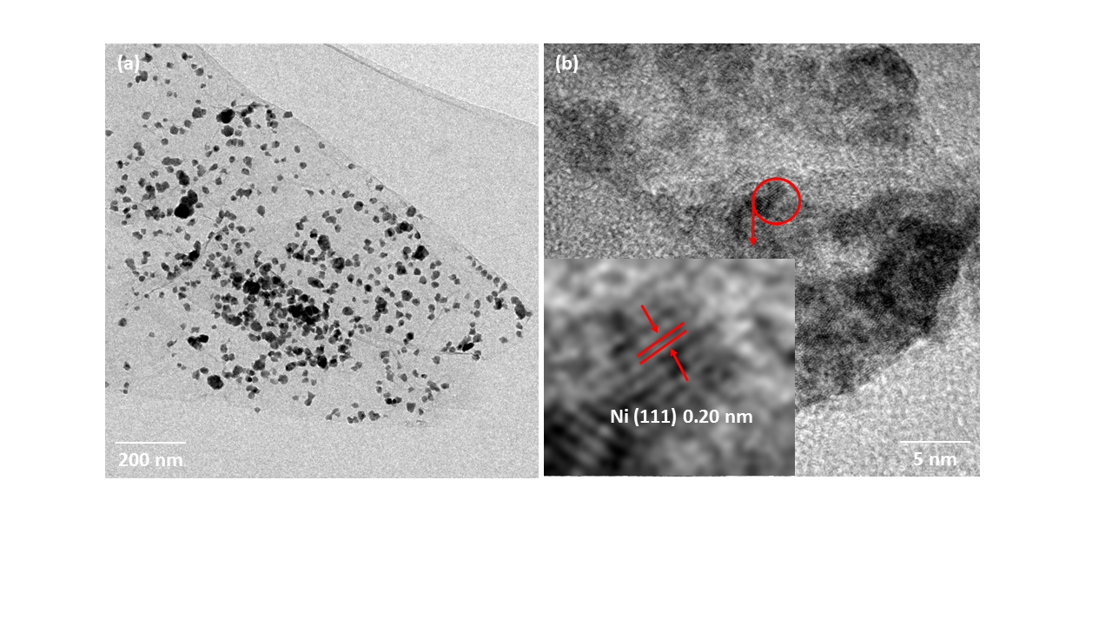

Fig. 1 Nickel decorated reduced graphene oxide synthesized using a novel route
Discussion should summarize the observations and attempts to place this data into the context of the existing body of literature to express opinions about the significance of the work.
CONCLUSION
This short section is to summarise the work based on the facts in evidence and point out the main areas covered in the writing. It may also contain the future directions of the work.
REFERENCES
References must be numbered. Keep the same style.
1. S. Pinto et. al, Appl. Phys. Lett. 101, 063104 (2012)
ACKNOWLEDGMENTS
Authors can acknowledge any person, or funding agency that has made a significant contribution to the work.

